Survival Properties System

**Publisher**: Sagui Itay ([saguiitay@hotmail.com](mailto:saguiitay@hotmail.com))

**Website**: <http://www.saguiitay.com>

# Overview

Survival Properties System is a comprehensive properties system for creation of Survival games.

You have complete control over the list of properties, their decay, and their impact one over the over.

Properties such as health, hunger, thirst and energy interact together to give you a realistic status of the player. Additional properties, such as Poison, can be easily added for temporary effect.

## Features:

* Full, documented, source code included
* Easy to use
* Completely customizable
* Includes built-in visualization mechanism
* Comes with a great sample

Note: You need to install the following package to view the sample: [Free Low Poly Desert Pack](https://www.assetstore.unity3d.com/#!/content/106709?aid=1101lS3S) by [23 Space Robots and Counting...](https://assetstore.unity.com/publishers/21779?aid=1101lS3S)

Random Generator is a utility library that allows you to easily add random names to your game.

# How to use Survival Properties System

At its very core, Survival Properties System consist of a single script – PropertiesManager – which allows managing an unlimited number of properties. Just add the script to any object (e.g. your Player object), and add the properties you’d like:

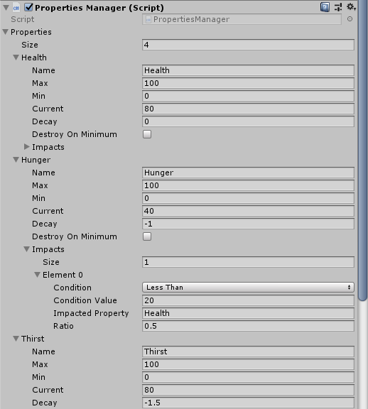

You can then use a PropertiesVisualizer script to manage the display of the properties:

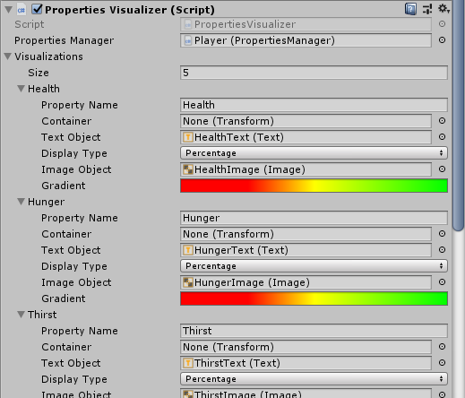

Survival Properties System comes with a fully functional sample scene, which includes:

* 4 Properties: Health, Hunger, Thirst and Energy
* Visualization for the 4 properties
* Interaction with objects that results in the current value of properties to be updated
* Interaction with objects that results in addition of temporary properties (e.g. Poison)